AiM: How to Upload Related Documents for Properties, Locations, or Assets

This guide contains:
- Instructions for adding related documents
- Instructions for applying an uploaded image to a profile

It can be helpful to have documents such as leases, operating manuals, or images at your fingertips while using AiM. AiM provides the ability to attach these documents to the profile screen for any Property, Location, or Asset. It is a simple process to add related documents that any user can perform. It is the same whether you are in a Property, Location, or Asset profile. (For simplicity, this document offers the Property Profile as an example)

Once in the Property Profile:
- You must be in Edit mode in order to attach new documents. If you are not in Edit mode, simply click on the Edit button on the upper left side of the screen.
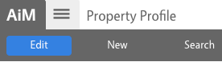

- Click on the Related Documents link on the left menu.
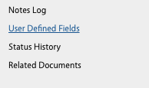

- Click on the Add button in the upper right side of the screen. This will open a wizard to add documents.

- The first screen of the “Related Documents” wizard lets you select the file you want to load. Depending on your browser you will get a slightly different screen. Click on the “Choose Files” or “Browse…” button and select the file you want to upload to AiM
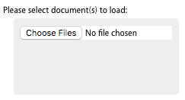

You can select the file and click open or just double click on the file you want to add. (browser specific)
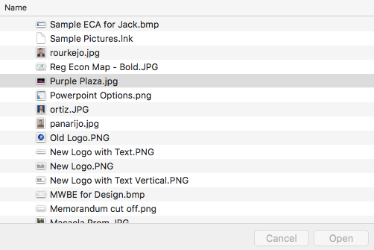

Then click the Next button in the upper left side of the “New Document” screen
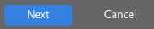

- The next screen allows for a detailed title of the document, select the type of document that you are attaching, and provide any tags to help you find your document.
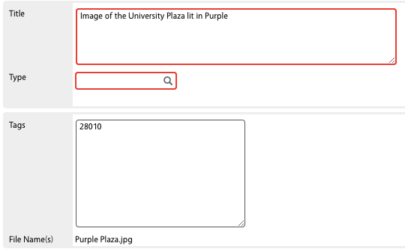

In the Title field, it is suggested that you include the name of the property or room

In the Type field, click the magnifying glass and select the appropriate document type. It is important that you select IMAGES if it is a picture.
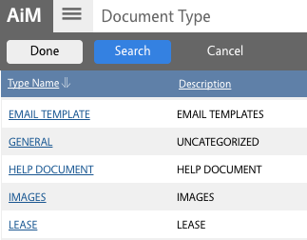

In the Tags field, it is important to include your 5 digit region or institution code as documents are filtered by this field so that other campuses do not see your documents.

Then click on the Next button in the upper left side of the screen

- The next screen in the wizard is used to add any attributes to the document. Attributes will be defined by the ongoing AssetWorks Committee.

Click on the Next button in the upper left side of the screen

- The next screen in the wizard allows you set permissions to limit who can see the document. Typically, you do not need to limit access, so click on the Next button in the upper left side of the screen.

- This will bring you back to the Related Documents screen and will show you the details of what you just added as well as a thumbnail of the document
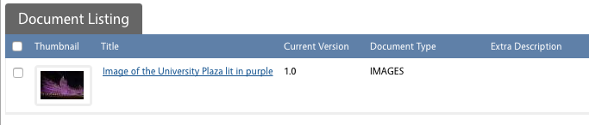

If you want to add another document, you can click the Add button in the upper right side of the screen. If you are done adding documents, you can click the Done button in the upper left side of the screen.

Be sure to click the Save button to ensure that the document is saved.

Using Images on Properties

If you uploaded an image and you want to use it for the picture associated with the property, location, or asset, you can use the following instructions to do so:

- Again, you must be in Edit mode in order to update the image for the property, location or asset you are using. If you are not in Edit mode, simply click on the Edit button on the upper left side of the screen.

- To select the picture that you just attached to this record, click on the Edit button in the upper right side of the screen
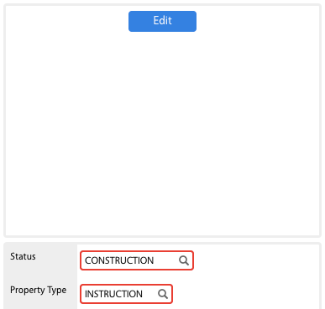

This will bring up a list of all the documents uploaded by your institution and can get pretty overwhelming. In order to find the document you want to use, click on the Search button in the upper right side of the screen
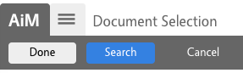

- On this screen you can enter information that will limit the documents to choose from.
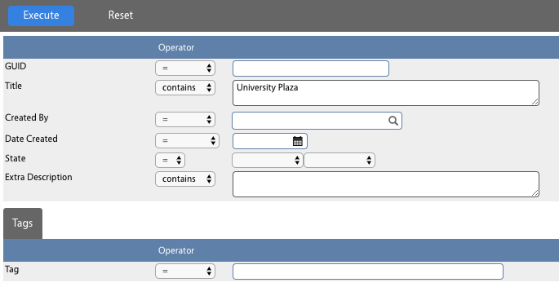

In this example, the title is limited to those containing “University Plaza”. By clicking on the Execute button, you will be presented with the images that match your search criteria.
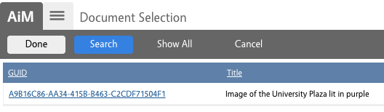

Click on the link to select the image you want to use and the profile will be updated with that image:

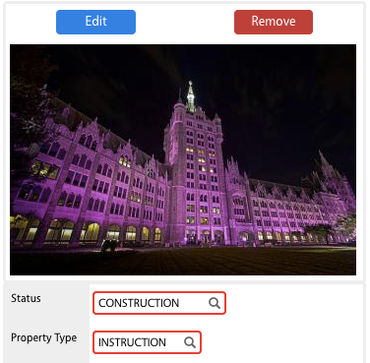

Be sure to Save your profile.

