The State University
Nancy L. Zimpher
Chancellor

of New York State University Plaza
Albany, New York 12246

November 30, 2012

Dr. Kenneth P. O'Brien
President, University Faculty Senate
State University Plaza
Albany, New York 12246

Dear Dr. O'Brien,
www.suny.edu

Thank: you for your letter of May 21, 2012, which included summaries of the five resolutions passed at the University Faculty Senate's Spring 2012 Plenary. Please forgive my delay in getting this formal response to you. You and I have had the opportunity to discuss several of these matters over the past few months, but I am pleased to respond below to the specific resolutions passed at the May meeting. Note, too, that I have read carefully the Sector Reports and your helpful summary of key issues raised.

• 161-01-1: SUNY Faculty Senate Resolution in Honor of Ed Alfonsin
A fitting tribute to a long-time colleague.

• 161-02-1: Resolution for a new Chancellor's Award for Shared Governance The Chancellor's Awards for Excellence program is a critically important means for SUNY to recognize and publicly express its pride in the accomplishments of our faculty, including the service of those who give of their time, experience and expertise to participate in shared governance. My understanding is that the Faculty Senate Awards Committee is currently working on selection criteria. Provost Lavallee assures me that when ready, language will be processed with
all due course for inclusion in the guidelines when next issued. As you know, I am open to ideas and suggestions regarding how we can bring the expertise of our distinguished faculty ranks to bear on system-wide challenges and opportunities.

• 161-03-1: Resolution to amend criteria for Distinguished Librarian and
161-04-1: Resolution to Support the Work of the Programs and Awards
Committee to Amend the Criteria of the Distinguished Service Librarian
I fully support both resolutions regarding the Distinguished Librarian award­ the first adding clarity, the second recognizing the previous omission of community college librarians from eligibility for this designation. My understanding is that these revisions are on track for inclusion in the guidelines when next issued.

To Learn To Search To Serve

the Power of

The State University of New York 12
UFS Spring 2012 Plenary Resolution Responses

• 161-05-1: Resolution of the University Faculty Senate Program and Awards Committee on the Inclusion of Clinical Faculty for the Chancellor's Award for Excellence in Teaching
I commend the University Faculty Senate Program and Awards Committee for addressing this issue and working to achieve equity in eligibility criteria for the Excellence in Teaching award. Again, I understand that the Faculty Senate Program and Awards Committee are working in conjunction with Provost Lavallee's staff to develop criteria specific to clinical faculty.

Thank you Ken, for your diligence in ensuring that I have not only a record of the important dialogue that takes place at each plenary but a summary of your keen insights about the critical questions and concerns raised.

Sincerely,
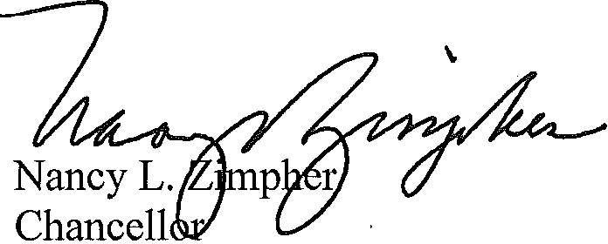

NLZ:cp/jfn/amf

cc: Dr. David Lavallee, Executive Vice Chancellor and Provost

