The State University
Nancy L. Zimpher
Chancellor

of New York State University Plaza
Albany, New York 12246

November 30, 2012 www.suny.edu

Dr. Kenneth P. O'Brien
President, University Faculty Senate
State University Plaza
Albany, New York 12246

Dear Dr. O'Brien,

Thank you for your letter ofNovember 20, 2012, which included summaries of the
three resolutions passed at the University Faculty Senate's Fall2012 Plenary. I was glad to join the group in person and, as always, extend my thanks to you and the faculty for the thoughtful, candid dialogue on the pressing issues before us.

I am pleased to respond here to the specific resolutions passed at the meeting:

• 162-01-1: Resolution for Support of Downstate Medical Center
Thank you for the expression of support for your faculty colleagues at Downstate. I share your appreciation for the many campus achievements/distinctions that the resolution highlights.

• 162-02-1: Resolution on the Need for Transitional Funding with the New
Resource Allocation Tool
This certainly resonated with my team at System as well as with campus leadership. As you know, we have now incorporated two features into the budget model designed to give campuses more time to plan for and adjust to modifications: 1) any changes would be rolled out over a three-year period; and 2) enrollment calculations will be based on a three-year rolling average. We are setting aside funding for three years of transition aid and anticipate that some campuses, based on the extent of change, may require alternate arrangements. Provost Lavallee has assured me that he will work with campuses accordingly.

• 162-03-1: Resolution on Necessity of Campus Presidents
As you know, we are working with the Board of Trustees to develop guidelines/processes for those campuses with shared leadership to consider presidential searches. As we review what we have learned and achieved to date, I know that we will move forward in a direction that best supports the needs of our students, faculty and campus communities. My understanding is that the alliances between sharing campuses in some cases have already resulted in savings

To Learn To Search To Serve

the Powerof SUNY

The State University of New York 12
UFS Fall 2012 Plenary Resolution Responses

significant enough to allow searches to begin in the near future, while maintaining achieved efficiencies. Consideration will be given to what the most beneficial next steps are for each of these campuses. As always, I look forward to your input, on behalf of your faculty colleagues, in that process.

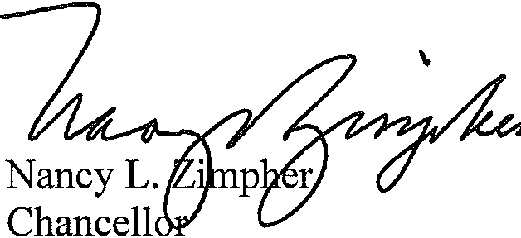Ken, thank you for your continued leadership and partnership. Sincerely,

NLZ:cp/jfn/amf

cc: Dr. David Lavallee, Executive Vice Chancellor and Provost

